**Task1**

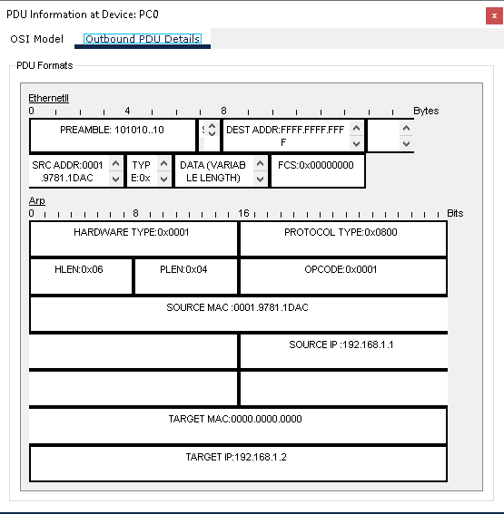

**Task2**

|  |  |  |
| --- | --- | --- |
| **Feature** | **Logical Mode** | **Physical Mode** |
| **Focus** | Network structure | Device details and configuration |
| **Presentation** | Abstract, no physical devices | Detailed, shows physical devices and connections |
| **Configuration** | Simplified templates | Command-line interface (CLI) |
| **Usefulness** | Quick visualization, basic network setup | Detailed simulation, troubleshooting, advanced configuration |